**Is gaming a stress buster?**

Well, the gaming industry is no short way from ancient history to this decade. There have been various releases and advancements boosting the gaming market every now and then. From Snake and ladders in that keypad phones to the blockbuster PUBG, Ludo King, and others we have traveled a huge journey in the gaming industry.

With the global variations caused in the gaming industry by mobile games, the Global games market has 50% games being the mobile ones. The gaming industry experiences huge expenditure and revenue generation for the whole year. With high revenue generation in the gaming field, it is expected to reach $174 billion in 2021. With various effective qualities, these mobile games have managed to entertain 2.4 billion people in 2019. There reach has been expanding from villages to metro cities with fantastic releases and engaging features with easy accessibility. Team of researchers examined around 1,000 gamers and players and found that out of them, 55% are the ones who believe that games help unwind and relieve stress and tension.

There are various shreds of evidence that mobile gaming has managed to provide an un-ending entertainment to all the generations from kids to the working class and the older people. With anywhere access to the game, they have been the best source of recreation and refreshment for numerous folks worldwide. Also, these mobile games help relieve stress and relax the mind. The mobile game players have reported exhibiting relaxation and minimal to no stress by the end of the days. And, reports have stated how stress relieves more by each passing day that is spent on playing games. In the gaming genres, hyper-casual games have been proved to be the most preferred for refreshment and stress relieving with their ease in starting, playing, and ending. These tap-to-play hyper-casual games have simple and decent UI that does not require any tutorial or extra knowledge and helps relax with the game-play of even the few minutes.

Between the work tensions and the study pressures, engaging in the mobile game during the breaks helps boost the energy and bursts the stress for more focus and concentration. Mindfulness apps are also there but they only tend to prompt relaxation. However, mobile gaming, on the other hand, provides all relaxation, mastery, sense of control, and psychological detachment. The sense of excelling in the game-play and enhancing various skills with hyper-casual games like color-selection and identification, time management, and others improvises the sense of mastery in the players, making them motivated and enthusiastic. Also, games’ engagements provide necessary detachment that ensures no stressed thinking for the time being and hence helps the mind to relax.

Stress and tension lead to various harmful effects on the lives of people and also pushes them towards the deep darkness. However, gaming is the most crucial stress buster to help every age group from children to the workaholics and the oldies to stay joyous and stress-free.

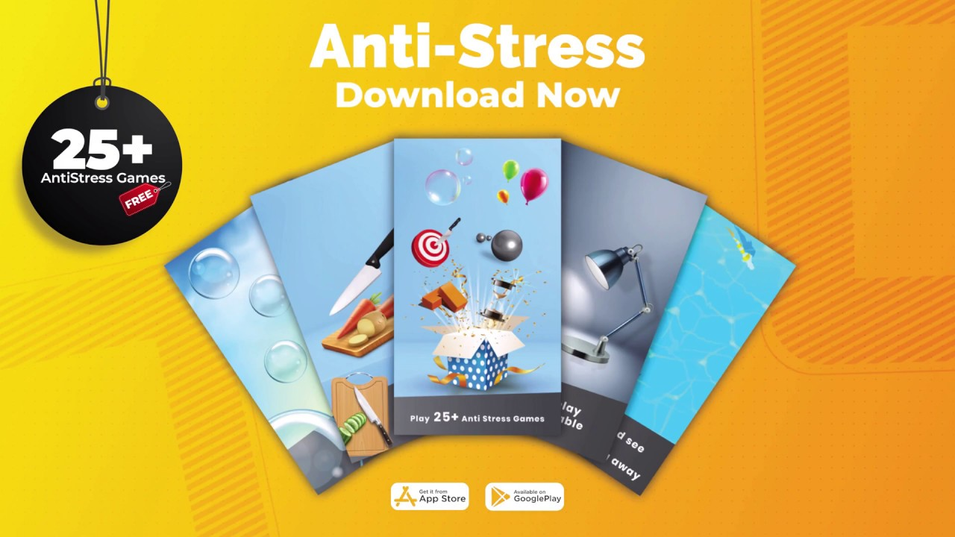

**Top games as stress busters:**

More than half of America’s population experiences fatigue due to work or other stress, frustration, and anxiety. Breaks during working or studying hours can be a lot more motivating and energizing with the help of mobile games, especially the hyper-casual ones. Many games have managed to mark their presence as the stress busters, like:

1. **Paper Toss:** School days were a lot more entertaining with small game-plays like throwing the crushed paper balls or the foil balls into the bins. This game is a similar mobile version of the old play. Considering the obstacles, the proper toss is to be made to land the ball into the basket. This game reminds the old school days and hence brings joy and entertainment into the lives.
2. **Glow Hockey:** This glowing game experience is incredible and energetic with its gaming technique similar to the Atari’s Pong. Colorful neon experience for hockey playing is highly relaxing with Glow Hockey. Also, this game is easy to play that only requires moving the fingers and hence is highly engaging and recommendable for the working class too.
3. **KAMI:** This is a puzzle game that requires screen filling with colorful sets of paper within the given number of moves. This game requires patience and creativity and helps with mental growth. Originated from the idea of Origami, this game is similar satisfying like the Japanese trend. KAMI is thus so engaging and hence stress bursting with its game-play technique.
4. **Color Zen:** Colorful gaming helps improve better color recognition and identification skill. This game involves crashing and spreading the colors across the play screen with the logic required for efficient filling. Color Zen also uses pleasing background music with a beautiful gaming screen to relieve stress and provide an admirable experience.
5. **Splice:** Micro-organisms are the most crucial parts of our daily lives. With this concept, Splice is about pulling apart and putting together various organisms to create the design sample given. This helps one experiment with various organisms and their structures. This game has various steps to experiment, get confused, and then get fascinated with your on-screen creations.
6. **Strata:** There are a set of ribbons available with several grids. One needs to be creative in filling up those ribbons inside the grids. Also, the ribbons need to match the colored square given in the grids. Strata is an anti-undo game that needs finishing up within one chance at a single go.

These are several stress busters that have been helpful for various age groups irrespective of their genders. These games have provided immense pleasure and satisfaction with easy playing and engaging environment. These games have also managed to relieve stress with their fascinating views.

Game App Studio also helps with creative and effective game developments for a stress bursting game with a team of expert and experienced developers and designers.

Stress-relieving now requires no other exercise with engaging and cheerful game-plays.